**Project Planning Phase**

**Project Planning(Product Backlog, Sprint Planning, Stories, Story points)**

|  |  |
| --- | --- |
| Date | 14 November 2022 |
| Team ID | PNT2022TMID41055 |
| Project Name | Smart Fashion Recommender Application |
| Maximum Marks | 8 Marks |

**Product Backlog, Sprint Schedule, Estimation**

|  |  |  |  |  |  |  |
| --- | --- | --- | --- | --- | --- | --- |
| Sprint | Functional Requirement | User Story | User Story / Task | Story points | Priority | Team Members |
|  | (Epic) | Number |  |  |  |  |
| Sprint-1 | Setting up App environment | USN-1 | As a user, I can register in ICTA Academy and create IBM cloud account. | 2 | High | Teresa H |
| Sprint-1 |  | USN-2 | As a user, I will create a flask project | 1 | Low | Gokula Priya R |
| Sprint-1 |  | USN-3 | As a user, I will install IBM Cloud CLI | 2 | Medium | Mariya  Chrispin  Sharmina A |
| Sprint-2 | Setting up App environment | USN-4 | As a user, I can install Docker CLI | 1 | Low | Shekinah  Dorothy A |
| Sprint-2 |  | USN-5 | As a user, I will Create an account in sendgrid | 2 | Medium | Teresa H |

|  |  |  |  |  |  |  |
| --- | --- | --- | --- | --- | --- | --- |
| Sprint-3 | Implementing web | USN-6 | As a user, I Create UI to interact | 1 | High | Gokula Priya R |
|  | application |  | with the application |  |  |  |
| Sprint-3 |  | USN-7 | As a user, I Create IBM DB2 and | 3 | High | Shekinah |
|  |  |  | connect with Python |  |  | Dorothy A |
| Sprint-3 | Integrating sendgrid | USN-8 | As a user, I will integrating sendgrid | 2 | High | Mariya |
|  | service |  | with python code |  |  | Chrispin  Sharmina A |
| Sprint-3 | Developing a chatbot | USN-9 | As a user, I have to build a chatbot and Integrate to application | 1 | Medium | Gokula Priya R |
| Sprint-4 | Development of App in | USN-10 | As a user, I will Containerize the | 1 | Low | Mariya |
|  | IBM Cloud |  | App |  |  | Chrispin  Sharmina A |
| Sprint-4 |  | USN-11 | As a user, I will upload image to IBM Container registry | 2 | Medium | Shekinah  Dorothy A |
| Sprint-4 |  | USN-12 | As a user, I will deploy App in Kebernetes cluster | 3 | High | Teresa H |
| Sprint-4 | User panel |  | As a user   * Register, Login, Email, Verification * Manual Search * Order placement, Order Details | 3 | High | Gokula Priya R |

**Project Tracker, Velocity & Burndown Chart**

|  |  |  |  |  |  |  |
| --- | --- | --- | --- | --- | --- | --- |
| Sprint | Total Story | Duration | Sprint Start Date | Sprint End Date | Story Points | Sprint Release Date |
|  | Points |  |  | (Planned) | Completed (as on  Planned End Date) | (Actual) |
| Sprint-1 | 18 | 6 Days | 31 Oct 2022 | 05 Nov 2022 | 24 | 29 Oct 2022 |
| Sprint-2 | 18 | 6 Days | 09 Oct 2022 | 15 Nov 2022 | 24 | 05 Nov 2022 |
| Sprint-3 | 18 | 6 Days | 02 Nov 2022 | 08 Nov 2022 | 24 | 12 Nov 2022 |
| Sprint-4 | 18 | 6 Days | 08 Nov 2022 | 14 Nov 2022 | 24 | 19 Nov 2022 |

# Velocity

Imagine we have a 6-day sprint duration, and the velocity of the team is 18(points per sprint). Let’s calculate the team’s average velocity (AV) per iteration unit (story points per day)

AV = Sprint Duration / Velocity

AV=24/6=4

# Burndown Chart

A burn down chart is a graphical representation of work left to do versus time. It is often used in agile software development

methodologies such as Scrum. However, burn down charts can be applied to any project containing measurable progress over time.

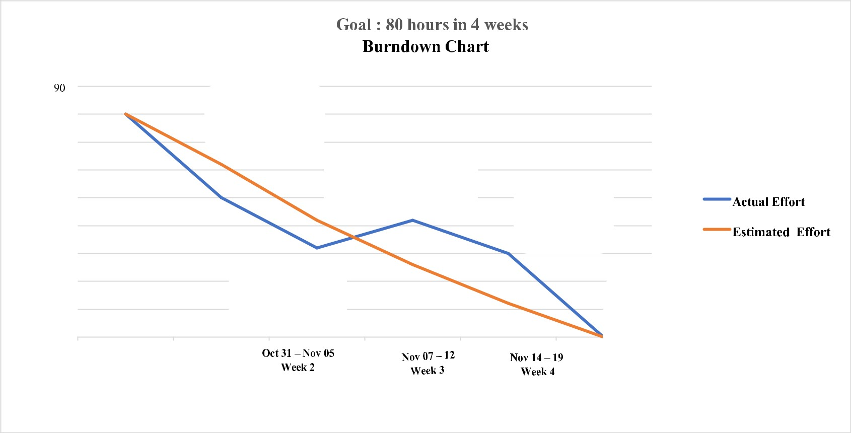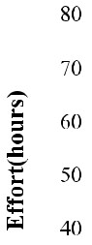

Setting

up

App

Environment

Integrating

sendgrid

service

Developing

a chatbot

Implementing

web

App

Deployment

of

app

in

IBM

Cloud

**Oct**

**31**

**-**

**2**

**9**

**Week**

**1**